Towards the use of Simulated Environments to Evaluate Transformer-based Prosthetic Regression Algorithms

AP Research
Word Count: TBD

1 Introduction
Lower-limb amputation presents a substantial public health and rehabilitation challenge in the United States, with transfemoral (above-the-knee) amputations representing a major subgroup of roughly 40-45% of all lower-limb amputations (Dillingham et al., 2002; Pran et al., 2021). Importantly, transfemoral amputees lose the knee joint, making common tasks such as walking, running, sitting, and navigating uneven terrain energetically costly due to the uneven gait between the lower limbs. Even with microprocessor-controlled knees, users often experience slower walking speed and expend significantly more mechanical work (energy) per stride (Pinhey et al., 2022). Because functional outcomes vary widely across individuals with differing biometric data and amputation cause, an effective control system must truly adapt to changing conditions rather than optimizing for the “average” solution across its training domain.
One prominent challenge in transfemoral amputation is the absence of direct physical information about the knee joint, which is often partially or wholly missing. To operate at an acceptable standard, control algorithms must instead infer knee kinematics from nearby biomechanical and neuromuscular signals, such as from non-invasive sensors placed on the surface of the muscle, surface electromyography sensors (sEMG), which measures the electrical signals of specific muscle groups, and inertial measurement units (IMUs) on the upper leg or pelvis, which provide an accurate method of determining joint angles, data useful in kinematic calculations. However, sEMG signals are inherently noisy, non-stationary (their statistical characteristics change over time), vary with fatigue, and are at times impeded by skin and electrode placement (Zhang et al., 2022; Huang et al., 2008; Lin et al., 2024). Moreover, IMUs provide only kinematic context without neuromuscular intent, meaning that, while they are a source of important data regarding the current situation of the leg, they lack the information to predict the gonial angle of the knee, the consensus goal of autoregressive (generating from limited data) prosthetic algorithms. The task of mapping these disconnected inputs to knee motion constitutes a complex nonlinear regression (prediction) task requiring models capable of extracting time dependencies and context across multiple frequencies (eg, fast-twitch reactions vs. continuous flexion) of sEMG signals.
Although deep learning approaches (e.g., CNNs, RNNs, LSTMs) have improved continuous knee-angle prediction from wearable data, models are typically evaluated solely through numerical accuracy metrics without verifying that the predicted joint trajectories would produce viable locomotion in practice. This study examines whether statistical model performance (e.g., RMSE, MAE, R² computed through cross-validation) aligns with functional locomotion outcomes in a physics-based virtual simulation, for continuous knee-angle prediction using a transformer-based regression framework trained on sEMG and IMU inputs.
1.1 Current Methods for Knee-Angle Prediction
Before deep learning, knee-angle estimation relied primarily on classical regression such as support vector regression (SVR), relevance vector regression (RVR), and Gaussian processes. Li and Guan et al. (2023) employed multiple-kernel RVR to map thigh sEMG to continuous knee-angle trajectories, achieving a mean absolute error (MAE) of 3.27° and $R^{2}=0.895$. Although such methods perform well on small datasets, they rely on handcrafted features and lack mechanisms for modeling temporal continuity. Deep-learning regression methods integrate feature extraction and sequence modeling into a single framework. CNN and LSTM architectures can learn spatiotemporal dependencies directly from raw or minimally processed EMG and IMU signals. In many comparative studies, these models outperform classical regressors in both accuracy and generalizability, though often at higher computational cost (Zhu et al., 2021; Zhang et al., 2022; Liang et al., 2023; Keles et al., 2023; Lin and He, 2024). Importantly, the Transformer’s non-sequential self-attention structure enables parallel processing of entire input windows, supporting both higher throughput and longer context modeling compared to recurrent alternatives.
1.2 Transformer Architectures in Biomechanical Time-Series Data
Transformers are a relatively new class of deep learning models introduced by Google researchers (Vaswani et al. 2018), which have since revolutionized large language processing through attention-based mechanisms, a type of machine learning model inspired by human cognitive attention that emphasizes nuanced connections between sections of the input data. Recently, they have been extended beyond language tasks to sequential data, specifically time-series data, and have shown strong performance in predicting joint kinematics and muscle activation sequences from data collected with wearable sensors.
Liang et al. (2023) introduced a novel deep learning architecture (TCCT) based on the Transformer, which combines multi-channel sEMG and IMU data for continuous knee-angle prediction. Their model achieved high accuracy ($R^{2}=0.96$) and sub-12 millisecond inference latency, outperforming standards set by previous models such as Convolutional Networks (CNNs), Recurrent Neural Networks (RNNs, GRUs), and Long-Short Term Memory (LSTM) networks, architectures that specialize in identifying visual or spatial patterns in data. Similarly, Lin and He (2024) proposed a rotary transformer, or RoFormer, to estimate finger joint kinematics from sEMG, demonstrating generalization across subjects through adversarial transfer learning. The RoFormer improved on previous benchmarks from LSTMs and CNNs, displaying great aptitude with respect to the more complex task of finger control. Another application of transformers on a similar task, Li and Zhang et al. (2023), constituted a multi-task framework to predict joint angles of the hand, which simultaneously predicts gesture type and muscle force, achieving robust cross-task generalization. Lin et al. (2025) further improved on computation time by using only data from wearable sEMG sensors and achieving a Root Mean Squared Error (RMSE), a common statistic for quantifying regression error, of 7.26 ± 0.32 degrees and prediction times of 2ms on an RTX 4060 GPU, comparatively surpassing results from LSTM, GRU, and conventional transformers. Collectively, these works confirm that attention-based models can handle the complexity of biomechanical time-series and generalize effectively across sessions and subjects while maintaining real-time latency—critical traits for adaptive prosthesis control.
1.3 Simulation of Virtual Prosthetics
The primary problem with the current evaluation metric of cross-validation RMSE is that prediction accuracy alone does not guarantee true usefulness of the prosthetic in an actual kinematic context. Joint-angle regressors, such as the methods described above, are only valuable if their outputs are biomechanically plausible when considered in the context of whole-body motion. This gap between statistical error and real-time function has already been examined in myoelectric control research. Hargrove et al. (2007), for example, evaluated a pattern-recognition controller through a real-time virtual environment rather than solely reporting classifier accuracy. Similarly, Krasoulis et al. (2019), showed that prosthetic finger performance improved with user practice and could not be reliably inferred from machine learning statistics alone. Together, these studies suggest that a low RMSE could hide functionally poor control of the prosthetic. Physics engines such as MuJoCo have allowed accurate simulation of articulated bodies under controlled conditions (Todorov et al., 2012), providing a useful intermediary for simulating human movement. Microsoft’s MoCapAct database, through the AI method of reinforcement learning, allows the physical simulation to be grounded on real movement data recorded through motion capture (Wagener et al., 2022). The simulation route has many upsides, avoiding the safety and logistical challenges of real human-subject trials while still empirically testing whether a prosthetic model is compatible with balance, support, and responsive movement.

2 Methodology
This study used a window-based evaluation design to test whether lower prediction error from a transformer-based knee-angle regressor corresponded to safer simulated prosthetic behavior. Sensor data were recorded over time from the lower leg, and split into segments, or windows, each constituting one “trial”. Trials progress through four stages: (a) signal preprocessing, (b) training the transformer and generating predictions, (c) extrapolation of the window, consisting only of leg data, to a MoCapAct snippet containing simulation data for the entire body, and (d) simulating the MoCapAct motion while overriding only the right knee joint with the motion predicted by the prosthetic algorithm. This design connects the model’s numerical error directly to whole-body balance outcomes in simulation, rather than assuming that RMSE alone is sufficient evidence of success.

Parameter | Value | Significance
Sample rate | 200 Hz | Keeps every window equal in duration across recordings
EMG feature window | 32 raw samples (~80 ms) | Extracts important details of recent muscle activity; each window is used to compute the per-sensor features
Per-sensor features | RMS, MAV, WL, ZC, SSC, 8 FFT bands | Standardized EMG features describing muscle activity in multiple contexts
Model window length | 200 timesteps (1.0 s) | The constant length of each sample window for both training and simulation
Transformer Parameters | d_model=128; heads=8; layers=3; d_ff=256; dropout=0.10 | Standard TST model parameters
Training schedule | 40 pretrain epochs + 20 fine-tune epochs | Idea from Zerveas et al. (2021)
Optimizer | RAdam; batch size=64; learning rate=3e-4 | Optimizer component of the model; effectively decides how it “learns” and improves on error
Outer evaluation split | Leave-one-file-out (LOFO) | Prevents windows from the same recording appearing in both train and test sets, accounting for higher correlation between samples in the same recording
Motion matching | Top-12 shortlist from ~2,589 MoCapAct snippets | Reduced search cost while retaining a large reference bank
MuJoCo knee actuator | kp=800, kd=40, force=800 | Parameters for overriding the right knee angle from the reference policy

Table 1. Inclusion of fixed parameters used for replicability.

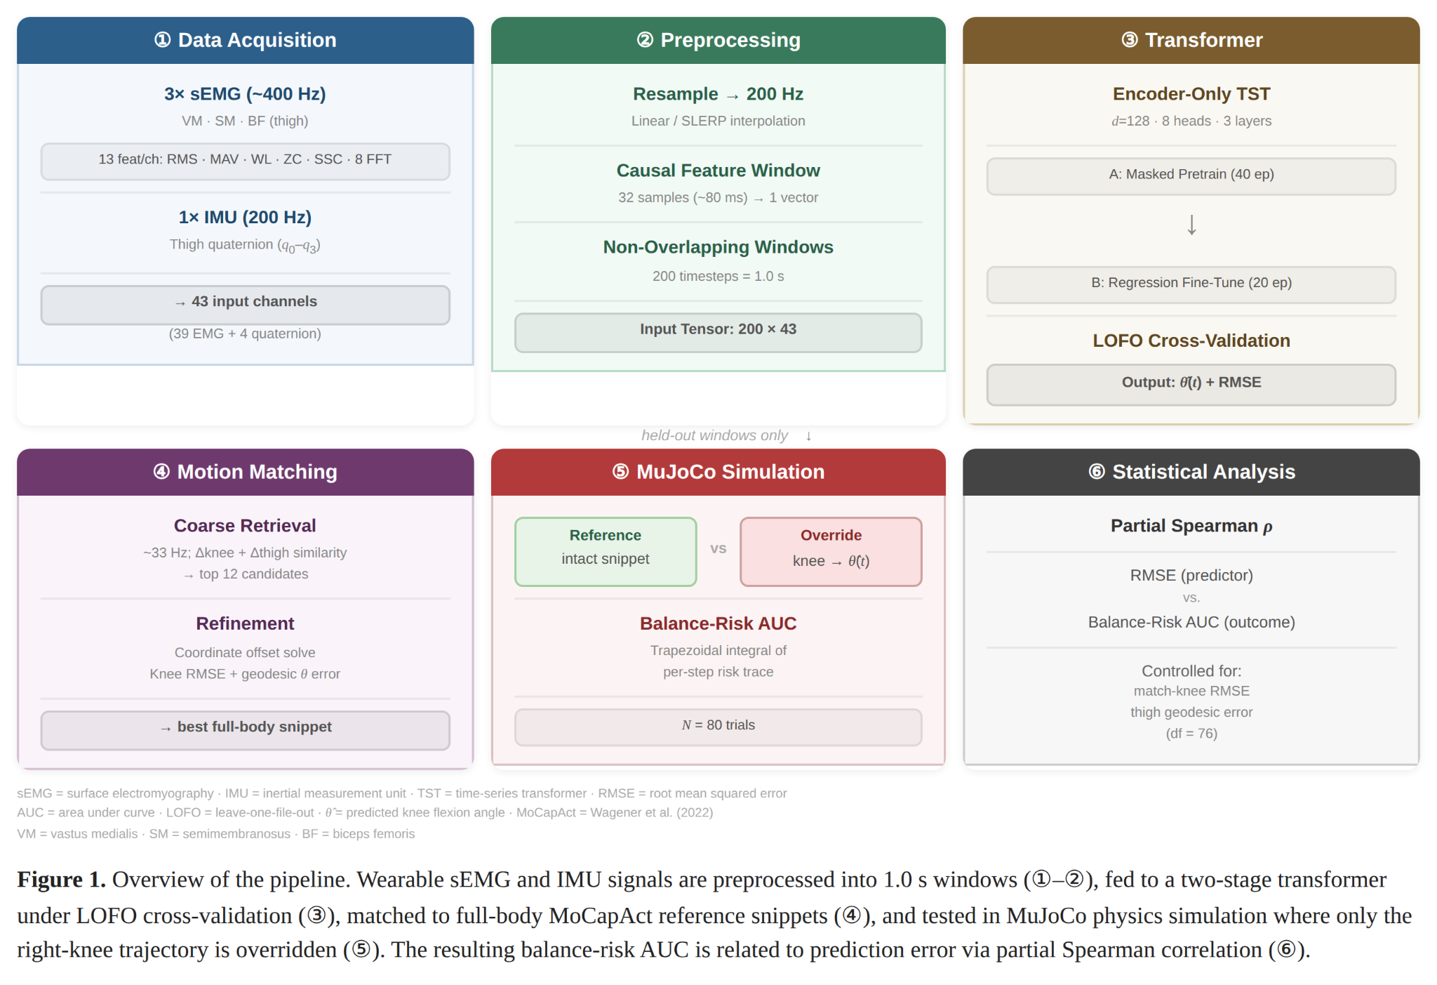
Figure 1. Overview of the preprocessing, prediction, motion-matching, simulation, and analysis pipeline.
2.1 Origin of Data and Ethical Scope
The wearable-data portion of the study used the researcher’s own recordings rather than recruited participants, and was approved by an IRB. Each recording session collected synchronized streams from three sEMG sensors on the upper right thigh, orientation data in the form of a quaternion from an integrated IMU onboard the sensors, and a “true” knee-angle (needed for the TST to learn from) calculated from the orientation data by software written by the researcher. The full-body reference motions used in matching and simulation were sourced from the public MoCapAct dataset from Microsoft researchers, which provides motion capture data grounded in a physics context through reinforcement learning (Wagener et al., 2022). Because this study used self-recorded data and public reference motions, it did not involve outside participants or identifiable health data.

2.2 Data Format and Feature Extraction
All recording channels were resampled by timestamp to a resolution of 200Hz so that each model-input window represented the same physical duration across recordings. Scalar channels were resampled linearly, whereas the thigh quaternion was interpolated and re-normalized to preserve a smooth 3D orientation trajectory (Shoemake, 1985). Raw EMG signals were available at the sensors’ native rate of 400Hz, and for each 200Hz timestep, a feature vector was computed from a window of the 32 most recent EMG samples. Thus, all features of the model were standardized to 200Hz.
For each of the three sEMG sensors, the pipeline computed 13 features at every timestep: root mean square (RMS), mean absolute value (MAV), waveform length (WL), zero crossings (ZC), slope sign changes (SSC), and eight fast Fourier transform (FFT) features. This feature set was chosen because time-domain descriptors such as RMS, MAV, WL, ZC, and SSC have long served as strong baselines in myoelectric control, while frequency features help capture changes in activation structure that pure amplitude features can miss (Hudgins et al., 1993; Chowdhury et al., 2013; Farina et al., 2014; Phinyomark et al., 2018). The 39 EMG-derived values were concatenated with the 4 thigh-quaternion components, yielding a 43-feature input vector at each timestep.
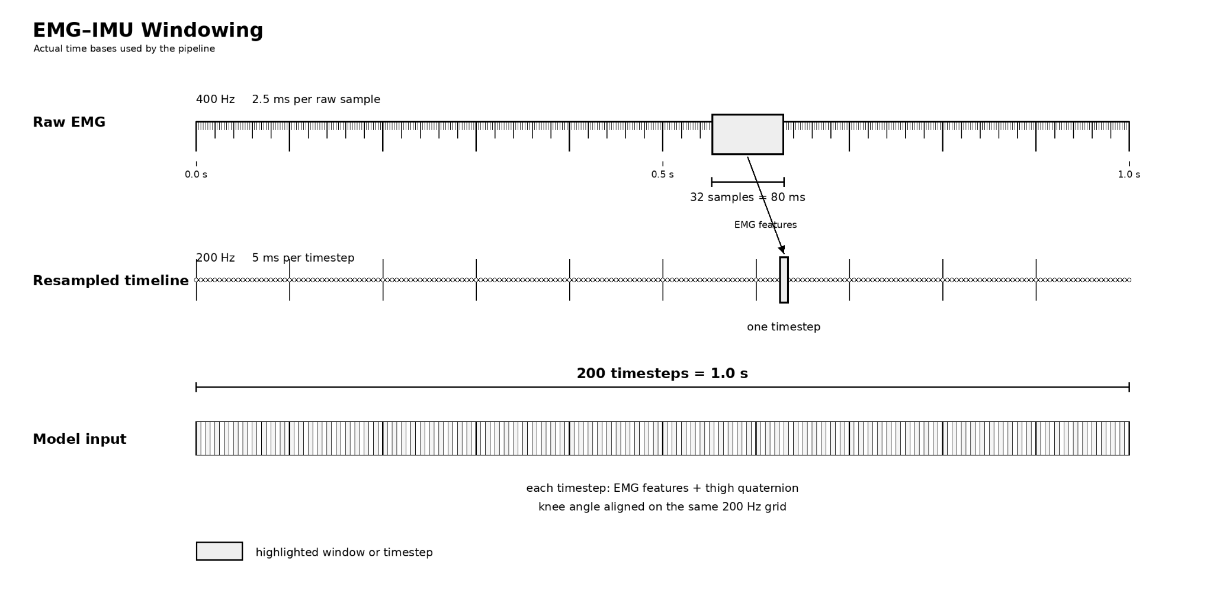
Figure 2. Windowing Process of Raw sEMG Data.
2.3 Windowing
After preprocessing, each recording was partitioned into consecutive, non-overlapping windows of 200 timesteps, equivalent to 1.0 second at 200Hz. Each window stored the full 200 × 43 input array, and the ground-truth knee angle trajectory over that window used to train the TST.
Non-overlapping windows were used intentionally so that neighboring samples would not share most of their content, creating a more diverse dataset. When nearby windows overlap heavily, especially in the same recording file where conditions are similar, a model can appear to generalize well simply because almost identical samples appear in both training and testing of the model. The decision to use non-overlapping windows and to isolate all windows from the same recording file into individual groups has precedent in studies such as Roberts et al., 2017, and Tougui et al., 2021).

2.4 Training
The prediction model was an encoder-only time-series transformer implemented in PyTorch. At each timestep, the 43 input features were linearly projected into a model dimension of 128 and combined with a positional embedding so the network could distinguish early from late timesteps within the 1.0-second sequence. Each encoder block then applied multi-head self-attention and a feed-forward layer with residual connections, and the fixed model settings were 3 encoder layers, 8 attention heads, a feed-forward width of 256, and dropout of 0.10 (Vaswani et al., 2017).
Training occurred in two stages. First, the model was pretrained with a masked-reconstruction objective adapted from transformer time-series representation learning, so it had to reconstruct masked portions of the multivariate input sequence (Zerveas et al., 2021). Second, the pretrained encoder was fine-tuned with a regression head to predict knee angle from the wearable-data window. Every fold used 40 pretraining epochs followed by 20 supervised fine-tuning epochs, with the RAdam optimizer, batch size 64, and learning rate 3 × $10^{-4}$. These values were fixed before the evaluation runs and were not changed between folds.
2.5 Cross-validation Strategy
Cross-validation was organized into inner and outer folds according to the decision to split independent files into their own test sets. The outer evaluation strategy was leave-one-file-out (LOFO) cross-validation. In each outer fold, one entire recording file was held out for testing, and all remaining usable files formed the development set. Within that development set, one additional file was reserved for validation because changing the model’s parameters based on the test data effectively nullifies its “blind” significance in evaluation. The number of outer folds was thus the number of usable recording files in the dataset.
Splitting by recording file rather than by random window was essential because windows from the same recording share local context, sensor placement conditions, and movement style. Mixing those windows across training and testing would risk overstating generalization. For each held-out window, the stored prediction metrics included knee RMSE, MAE, and R-squared, but the primary predictor used later in the correlation study was knee RMSE because it preserved the model's average angular error in the same degree units used by the simulator.
2.6 Motion Matching
Motion matching is a standard approach in real-time character animation and the video game industry, involving the retrieval of the closest motion snippet to another from a database using similarity metrics (Clavet, 2016). Prediction accuracy alone did not answer the research question because a model could produce a moderate RMSE while still generating a knee trajectory that destabilized the body when inserted into a whole-body motion. To provide realistic body context, each held-out window was therefore matched to a 1.0-second snippet from the MoCapAct reference bank. Before matching, the query window was resampled from 200 Hz to the MoCapAct control rate of approximately 33.33 Hz so that the wearable-data sequence and candidate reference sequences shared a common time base.
The matching itself used two stages. A coarse retrieval stage shortlisted the 12 best candidates by comparing change-over-time patterns in knee flexion and thigh orientation. A refinement stage then solved a constant coordinate-frame offset between the query and each candidate, aligned the sequences, and selected the single best match using two diagnostic scores: knee RMSE and thigh-orientation geodesic error in degrees. Geodesic rotation error was used because it measures disagreement between 3D orientations more appropriately than direct component-wise subtraction on quaternions (Huynh, 2009). Figures 3-5 show a representative prosthetic-override replay together with the two alignment diagnostics used to verify that the matched full-body snippet resembled the wearable-data query closely enough to support a meaningful simulation trial.
2.7 Simulation
After a window had been matched to a reference snippet, that snippet was run in MuJoCo using the corresponding MoCapAct expert policy (Todorov et al., 2012; Wagener et al., 2022). The expert policy continuously tracked the matched full-body motion, but the right-knee trajectory was selectively overridden in the experimental condition. Two rollouts were therefore generated for each matched window. The first was a reference rollout that left the matched snippet unchanged. The second was an overridden rollout that replaced only the right-knee trajectory with the transformer's predicted sequence while leaving the rest of the body under the same matched expert policy, effectively simulating a prosthetic limb applied to the policy.
This design isolated the effect of the predicted knee signal as much as possible. Because the full-body command policy, the matched motion context, and the simulator settings were shared across the two rollouts, any instability observed in the overridden rollout could be interpreted as the consequence of substituting the model-predicted knee trajectory rather than from other extraneous variables, such as physiological differences in test subjects, which affect traditional in-vivo studies of prosthetics.

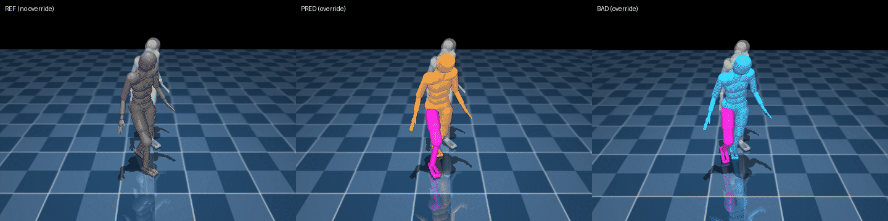
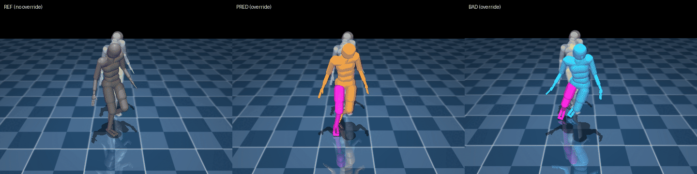
Figure 3. Two frames from three simulation rollouts across a 1.0-second evaluation window: the reference policy (grey), a model with low risk (orange), and a high-risk model (blue). The overridden leg is highlighted in pink.

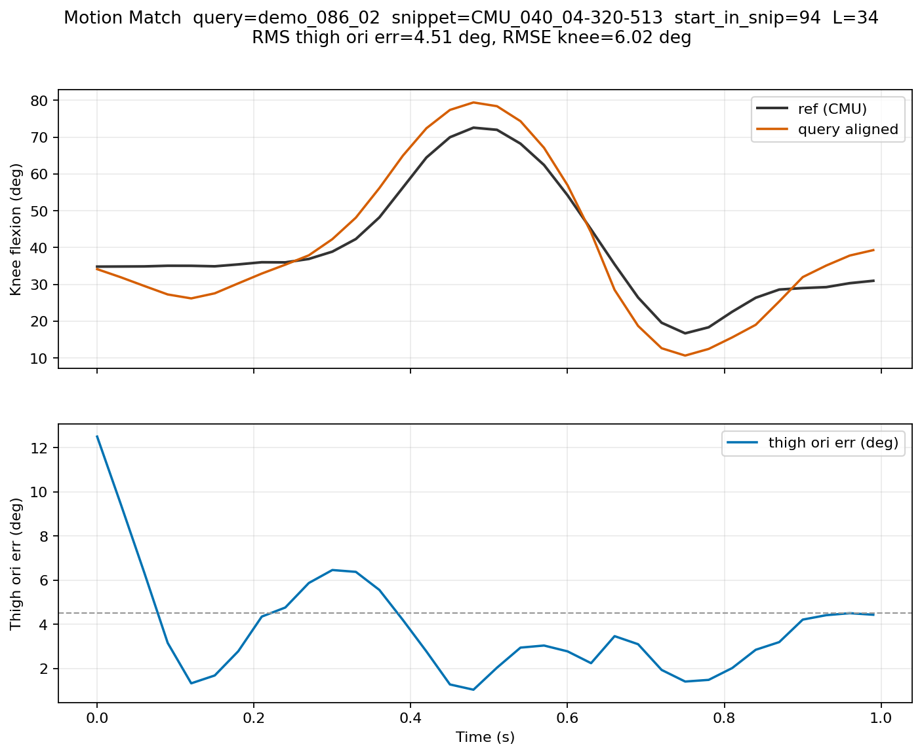
Figure 4. Example motion matching alignment showing the matched reference knee trajectory, the aligned query trajectory, and the thigh-orientation error over time.
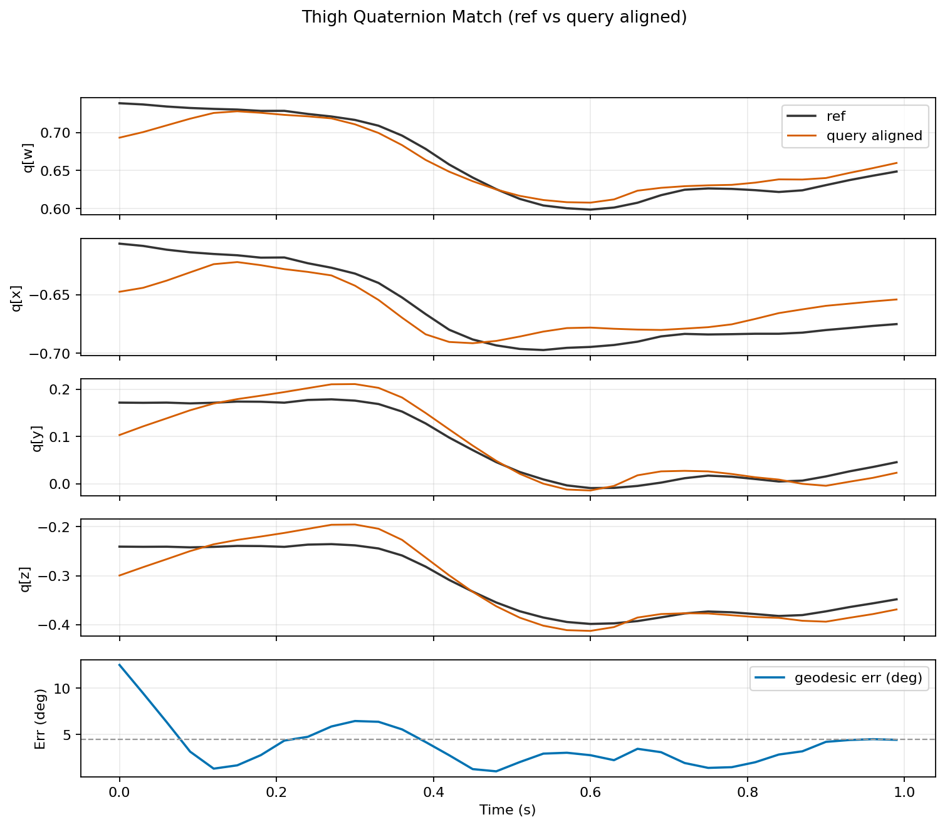
Figure 5. Example quaternion alignment after coordinate matching, with thigh-orientation error shown in the lower panel.
2.8 Outcomes
Simulation outputs were recorded over time for each rollout. The primary simulation outcome was a continuous fall-risk score derived from the simulator's balance heuristic, which combined uprightness and extrapolated-center-of-mass support-margin information across the rollout (Hof et al., 2005). This score was summarized over the 1.0-second window so that each motion-matched trial produced one scalar outcome representing physical risk.
The reason for using a continuous risk measure rather than only a binary fall flag was that many short rollouts do not end in a full collapse even when the motion is clearly becoming less stable. A continuous measure preserved more information about partial deterioration in balance.

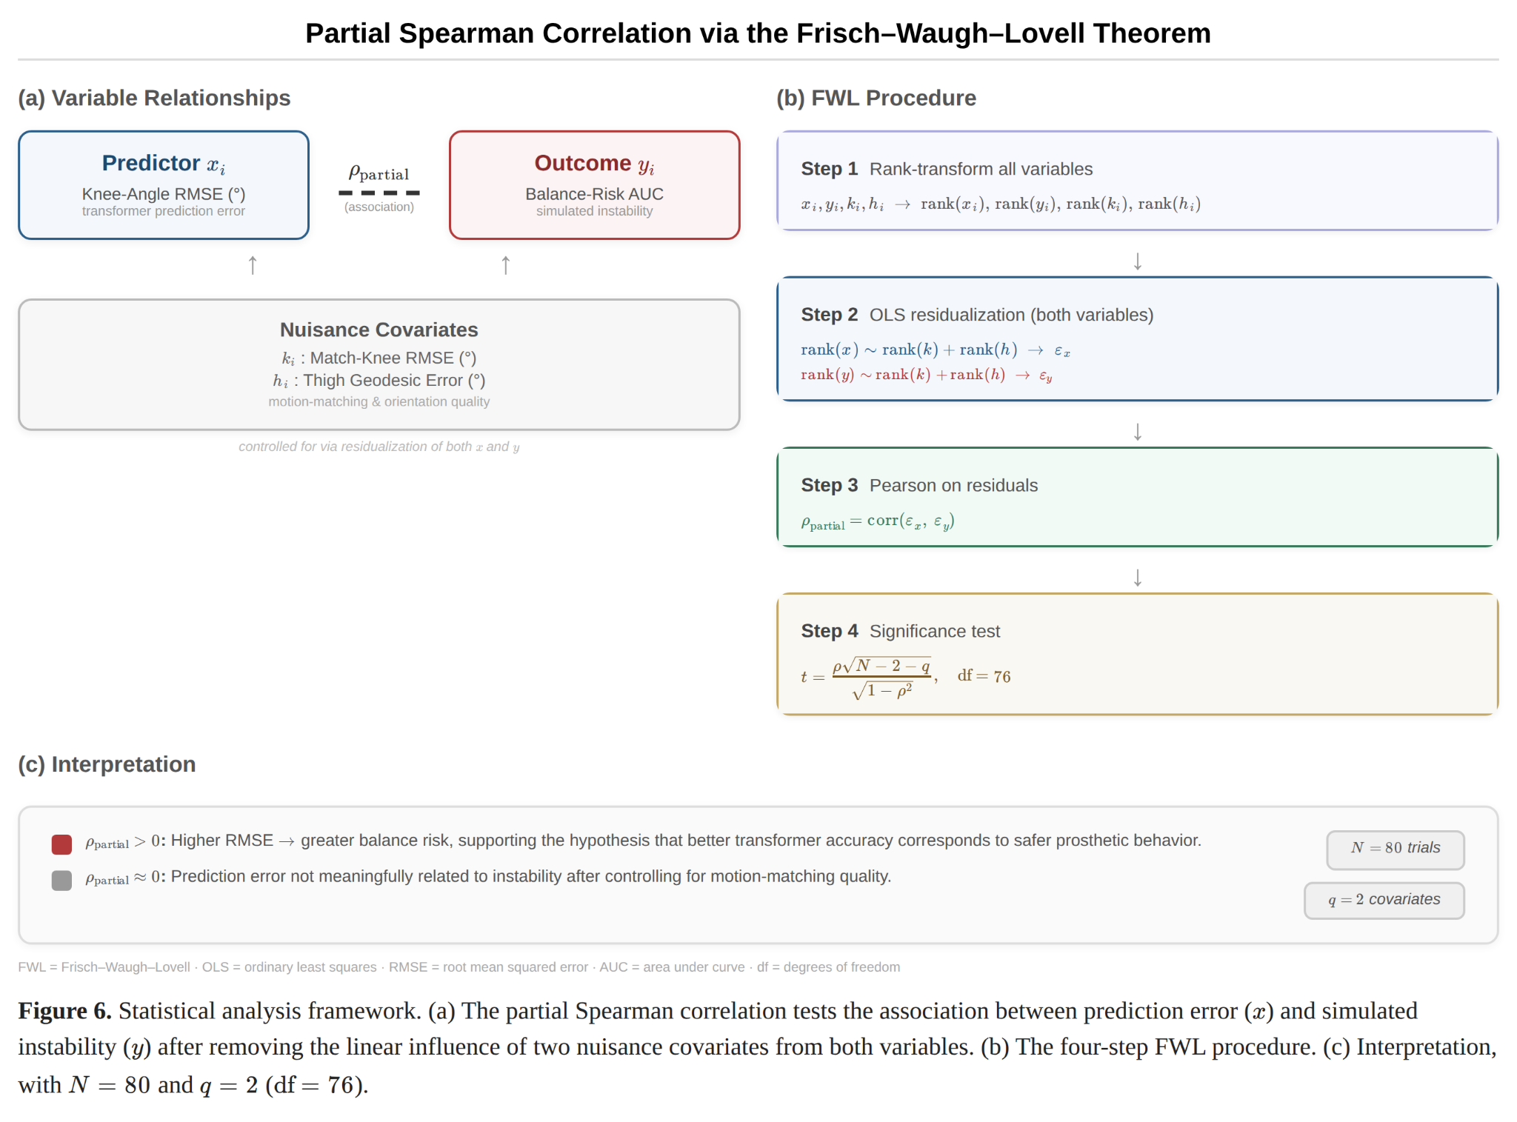
Figure 6. The statistical analysis framework.
2.9 Correlation Study
The candidate pool for physical evaluation consisted of the non-overlapping 1.0-second windows that had already been held out during the outer LOFO cross-validation folds. To keep the simulation study computationally feasible, 80 windows were selected uniformly at random without replacement from this held-out pool using a fixed random seed of 42. If a sampled window failed motion matching or did not complete simulation successfully, it was discarded and replaced by the next held-out window in the same seeded random order until 80 successful trials were obtained. In the end, each retained window was paired to a motion-matched simulation trial.
For each retained trial $i$, the primary predictor was $x_{i}$ the RMSE between the transformer's predicted knee angle and the ground-truth knee angle over the 1.0-second wearable-data window. The primary outcome was $y_{i}$, the area under the balance-risk curve from the corresponding prosthetic-override rollout. To account for the error introduced by motion matching itself, the Frisk-Waugh-Lovell theorem was used, which allows the relationship between two statistical variables to be discerned, even in the presence of confounding factors (Frisch & Waugh, 1933; Lovell, 1963). Two nuisance covariates were recorded: $k_{i}$, the RMSE between the matched-reference knee trajectory and the query knee trajectory, and $h_{i}$, the root mean squared geodesic error between the matched-reference thigh orientation and the query thigh orientation.
The association between prediction error and simulated physical risk was quantified with a partial Spearman correlation. Specifically, $x_{i}$, $y_{i}$, $k_{i}$, and $h_{i}$were first converted to ranks. The ranked predictor and ranked outcome were then separately residualized with respect to the ranked nuisance covariates ($h_{i}$, $k_{i}$) using ordinary least squares (Frisch & Waugh, 1933; Lovell, 1963). The final association statistic was the Pearson correlation between these residuals, which is equivalent to a partial correlation on ranks and therefore yields a partial Spearman estimate (Spearman, 1904). This procedure tested whether windows with larger model-prediction error also tended to produce greater simulated instability after controlling for motion-matching quality.

References
Chowdhury, R. H., Mamun, R., Mohd, A., Bakar, Chellappan, K., & Chang, T. G. (2013). Surface electromyography signal processing and classification techniques. Sensors, 13, 9. https://doi.org/10.3390/s130912431
Clavet, S. (2016). Motion matching and the road to next-gen animation. https://www.gdcvault.com/play/1023280/Motion-Matching-and-The-Road
Dillingham, T. R., Pezzin, L. E., & MacKenzie, E. J. (2002). Limb amputation and limb deficiency: Epidemiology and recent trends in the united states. Southern Medical Journal, 95, 8. https://doi.org/10.1097/00007611-200208000-00018
Farina, D., Merletti, R., & Enoka, R. M. (2014). The extraction of neural strategies from the surface EMG: An update. Journal of Applied Physiology, 117, 11. https://doi.org/10.1152/japplphysiol.00162.2014
Frisch, R., & Waugh, F. V. (1933). Partial time regressions as compared with individual trends. Econometrica, 1, 4. https://doi.org/10.2307/1907330
Hargrove, L., Losier, Y., Lock, B., Englehart, K., & Hudgins, B. (2007). A real-time pattern recognition based myoelectric control usability study implemented in a virtual environment. 4842–4845. https://doi.org/10.1109/IEMBS.2007.4353424
Huang, H., Zhou, P., Li, G., & Kuiken, T. A. (2008). An analysis of EMG electrode configuration for targeted muscle reinnervation based neural machine interface. IEEE Transactions on Neural Systems and Rehabilitation Engineering, 16, 1. https://doi.org/10.1109/TNSRE.2007.910282
Hudgins, B., Parker, P., & Scott, R. N. (1993). A new strategy for multifunction myoelectric control. IEEE Transactions on Biomedical Engineering, 40, 1. https://doi.org/10.1109/10.204774
Huynh, D. Q. (2009). Metrics for 3D rotations: Comparison and analysis. Journal of Mathematical Imaging and Vision, 35, 2. https://doi.org/10.1007/s10851-009-0161-2
Keleş, Ahmet Dursun, Tuna, T. R., & Yucesoy, Can A. (2023). The use of nonnormalized surface EMG and feature inputs for LSTM-Based powered ankle prosthesis control algorithm development. Frontiers in Neuroscience, 17, 1158280. https://doi.org/10.3389/fnins.2023.1158280
Krasoulis, A., Vijayakumar, S., & Nazarpour, K. (2019). Effect of user practice on prosthetic finger control with an intuitive myoelectric decoder. Frontiers in Neuroscience, 13, 891. https://doi.org/10.3389/fnins.2019.00891
L, H. A., Gazendam, M. G. J, & E, S. W. (2005). The condition for dynamic stability. Journal of Biomechanics, 38, 1. https://doi.org/10.1016/j.jbiomech.2004.03.025
Li, H.-B., Guan, X., Li, Z., He, L., Wang, Z.-H., & Cai, K. (2023). Estimation of knee joint angle from surface EMG using multiple kernels relevance vector regression. Sensors, 23, 10. https://doi.org/10.3390/s23104934
Li, X., Zhang, X., Chen, X., Chen, X., Liu, A., & Zhou, P. (2023). A transformer-based multi-task learning framework for myoelectric pattern recognition supporting muscle force estimation. IEEE Transactions on Neural Systems and Rehabilitation Engineering, 31, 3230–3240. https://doi.org/10.1109/TNSRE.2023.3298797
Liang, T., Sun, N., Wang, Q., Bu, J., Li, L., Chen, Y., Cao, M., Ma, J., & Liu, T. (2023). sEMG-Based end-to-end continuous prediction of human knee joint angles using the tightly coupled convolutional transformer model. IEEE Journal of Biomedical and Health Informatics, 27, 11. https://doi.org/10.1109/JBHI.2023.3304639
Lin, C., & He, Z. (2024). A rotary transformer cross-subject model for continuous estimation of finger joints kinematics and a transfer learning approach for new subjects. Frontiers in Neuroscience, 18, 1306050. https://doi.org/10.3389/fnins.2024.1306050
Lin, C., Zhang, X., & Zhao, C. (2025). A parallel and efficient transformer deep learning network for continuous estimation of hand kinematics from electromyographic signals. Scientific Reports, 15, 36150. https://doi.org/10.1038/s41598-025-16268-y
Lovell, M. C. (1963). Seasonal adjustment of economic time series and multiple regression analysis. Journal of the American Statistical Association, 58, 304. https://doi.org/10.1080/01621459.1963.10480682
Phinyomark, A., Khushaba, Rami N, & Scheme, E. (2018). Feature extraction and selection for myoelectric control based on wearable EMG sensors. Sensors, 18, 5. https://doi.org/10.3390/s18051615
Pinhey, S. R., Murata, H., Hisano, G., Ichimura, D., Hobara, H., & Major, M. J. (2022). Effects of walking speed and prosthetic knee control type on external mechanical work in transfemoral prosthesis users. Journal of Biomechanics, 134, 110984. https://doi.org/10.1016/j.jbiomech.2022.110984
Pran, L., Baijoo, S., Harnanan, D., Slim, H., Maharaj, R., & Naraynsingh, V. (2021). Quality of life experienced by major lower extremity amputees. Cureus, 13, 8. https://doi.org/10.7759/cureus.17440
Roberts, D. R., Bahn, V., Ciuti, S., Boyce, M. S., Elith, J., Guillera-Arroita, G., Hauenstein, S., Lahoz-Monfort, J. J., Schröder, B., Thuiller, W., Warton, D. I., Wintle, B. A., Hartig, F., & Dormann, C. F. (2017). Cross-validation strategies for data with temporal, spatial, hierarchical, or phylogenetic structure. Ecography, 40, 8. https://doi.org/10.1111/ecog.02881
Shoemake, K. (1985). Animating rotation with quaternion curves. 245–254. https://doi.org/10.1145/325334.325242
Spearman, C. (1904). The proof and measurement of association between two things. The American Journal of Psychology, 15, 1. https://doi.org/10.2307/1412159
Todorov, E., Erez, T., & Tassa, Y. (2012). MuJoCo: A physics engine for model-based control. 5026–5033. https://doi.org/10.1109/IROS.2012.6386109
Tougui, I., Jilbab, A., & Jamal, E. M. (2021). Impact of the choice of cross-validation techniques on the results of machine learning-based diagnostic applications. Healthcare Informatics Research, 27, 3. https://doi.org/10.4258/hir.2021.27.3.189
Vaswani, A., Shazeer, N., Parmar, N., Uszkoreit, J., Jones, L., Gomez, A. N., Kaiser, Ł., & Polosukhin, I. (2017). Attention is all you need. 30.
Wagener, N., Kolobov, A., Frujeri, F. V., Loynd, R., Cheng, C.-A., & Hausknecht, M. (2022). MoCapAct: A multi-task dataset for simulated humanoid control. 35, 35418–35431.
Zerveas, G., Jayaraman, S., Patel, D., Bhamidipaty, A., & Eickhoff, C. (2021). A transformer-based framework for multivariate time series representation learning. 2114–2124. https://doi.org/10.1145/3447548.3467401
Zhang, S., Lu, J., Huo, W., Yu, N., & Han, J. (2022). Estimation of knee joint movement using single-channel sEMG signals with a feature-guided convolutional neural network. Frontiers in Neurorobotics, 16, 978014. https://doi.org/10.3389/fnbot.2022.978014
Zhu, M., Guan, X., Li, Z., He, L., Wang, Z., & Cai, K. (2022). sEMG-Based lower limb motion prediction using CNN-LSTM with improved PCA optimization algorithm. Journal of Bionic Engineering, 20, 2. https://doi.org/10.1007/s42235-022-00280-3

